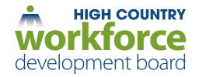
PY2018 Request for Intent to Bid for NCWorks Career Center Operations under
the Workforce Innovation and Opportunity Act (WIOA)

The High Country Workforce Development Board (HCWDB) is procuring services for the NCWorks Career Center Operator (One-Stop) as required under WIOA Final Rules section 678.605 (a)-(d) and DWS Policy Statement 19-2017 for the High Country region. Organizations with a history of operating WIOA programs are encouraged to apply. Completion of attached Letter of Intent Form is a requirement to participate in the full RFP process if deemed necessary. For additional information visit www.highcountrywdb.com.

Geographic Area to be Served: The High Country region includes seven counties in Northwest North Carolina. Due to the large geographical area, at a minimum it is expected that the following counties be included together for service delivery: Avery, Mitchell, and Yancey Counties; and Alleghany, Ashe, Watauga, and Wilkes Counties.

Available Funding: It is anticipated that contracts for center operations will be $20,000 for the service delivery area of Avery, Mitchell, and Yancey Counties and $30,000 for the service delivery area of Alleghany, Ashe, Watauga, and Wilkes Counties.

Service Delivery: The designated Operator will provide at a minimum: oversight of integrated service delivery as identified in High Country’s MOU; staffing; scheduling; identifying customer needs and process improvements; developing and supporting partnerships within workforce development; assisting with center certifications; coordination of staff meetings and trainings; and other duties related to operations in partnership with the WDB.

Deadline for Receipt of Intent to Bid Form is 5:00 pm on April 30th, 2018 by mail, email, or delivery. Late submissions will not be accepted. The completed form(s) are to be submitted to the High Country Council of Governments (HCCOG), the administrative entity for the Board’s Workforce Programs to the following:

Misty Bishop-Price
Workforce Development Department
High Country Council of Governments
468 New Market Boulevard
Boone, NC 28607
(828) 265-5434 ext. 119
misty.bishopprice@highcountrywdb.com

High Country Workforce Development Board Letter of Intent Form
WIOA NCWorks Career Center Operations
For Program Year 2018 (July 1, 2018 through June 30, 2019)

Through the completion of this form, our organization is acknowledging an interest to participate in HCWDB’s Request for Proposal procurement process to provide services as the NCWorks Career Center Operator.

The counties listed below are open for competitive bid through a Letter of Intent in the HCWDB’s service area. Please indicate which county or counties your organization is interested in bidding upon through the HCWDB’s Request for Proposal Process by writing or typing yes into the appropriate blank(s).

County(ies) | NCWorks Career Center Operator
Alleghany
Ashe
Avery
Mitchell
Watauga
Wilkes
Yancey

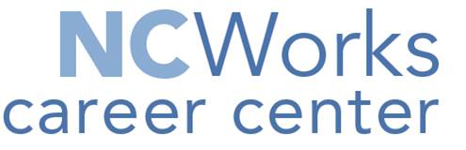
Authorized representatives of our organization have received and read the 2018 Intent to Bid specifications for the provision of WIOA NCWorks Career Center Operator, and we believe our organization is qualified to bid upon these services. We understand that receipt of this completed form by 5:00 pm on April 30th, 2018 is a prerequisite for our organization’s participation in the HCWDB’s Request for Proposal process.

Organization Name:
Address/Phone/Email:
Name & Title of Signatory Authority:
Signature/Date:

